Space Colonization is like a box of chocolates,
YOU NEVER KNOW WHAT YOU’LL FIND!!!!

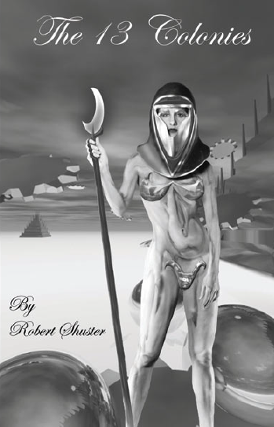
Other fine offerings from Sevenacide:
Sevenacide - sci-fi, horror, fantasy and…rugby players! This book is becoming a cult classic for both rugby playing and non-rugby playing fans. Only $7.00+Shipping

I, Vampire - The first full-length novel from Robert Shuster. Wander through the gritty world of Jacob Szabo and find out what it’s REALLY like to be vampire. Only $10.00+Shipping (Available Spring/Summer 2002)

Name______________________________________
Address____________________________________
_____________________________________
The 13 Colonies: _____copies@$10.00 each = $______
Sevenacide: ____copies @ $7.00 each = $_______
I, Vampire: ______copies @ $10.00 each = $______

Add $3.00 for 1st title & $1.00 for each additional title/US, $4.00 for 1st title and $2.00 each additional title/outside the US
Shipping = $______ Total Enclosed = $___________

Please allow 2-4 weeks for delivery (4-6 weeks outside the USA)

The 13 Colonies is a collection of thirteen short stories that takes a look at what the people of Earth might discover when they journey to other worlds (and vice-versa!) Only $10.00+Shipping

Mail your check or money order to:
Sevenacide
PMB #325
244 Shopping Avenue
Sarasota, FL 34237-7125

Make checks/money orders payable to “Sevenacide”

Visit www.sevenacide.com for upcoming signings, book releases, and other news!

“Dangerous Literature for an Unsuspecting World”

